**Our Energy Future**

**Petroleum**

*What is petroleum?*

The etymology of the word petroleum comes from the Latin *petra* (rock) and *oleum* (oil), and can defined as:

*Thick, flammable, yellow-to-black mixture of gaseous, liquid, and solid hydrocarbons* (carbon and hydrogen compounds) *that occurs naturally beneath the Earth’s surface*

Also known as crude oil, petroleum is a mixture of hydrocarbons with variable amounts of organic and inorganic substances such as sulfur, nitrogen and oxygen along with metal ions such as iron, vanadium, nickel and chromium. Crude oil contains anywhere between 100,000 to 1,000,000 different compounds.

In summary, it is an incredibly complex mixture and the refining process separates the useful portions of the petroleum mixture based on the different boiling points of the different compounds included in petroleum.

*Where does petroleum come from?*

All the oil we have today came from plankton, microscopic plants and animals that live in the ocean, a pretty incredible feat considering how small plankton is (10,000 can fit on the head of a pin) and how much oil is available on Earth.

When plankton die, they fall to the sea floor and form a layer of organic material. If there is enough oxygen on the sea floor, animals will feed on the dead plankton, but if not, the organic layer of dead plankton accumulates. When the sea floor is deep enough and the resulting sediment contains more than 5% organic matter, that is known as *black shale*. The dark band in the picture shows a layer of organic materials, and when there is a lot of accumulation you can get thick bands of black shale.

As more and more sediment piles on top of black shale and the black shales gets buried, it becomes heated through the compression.

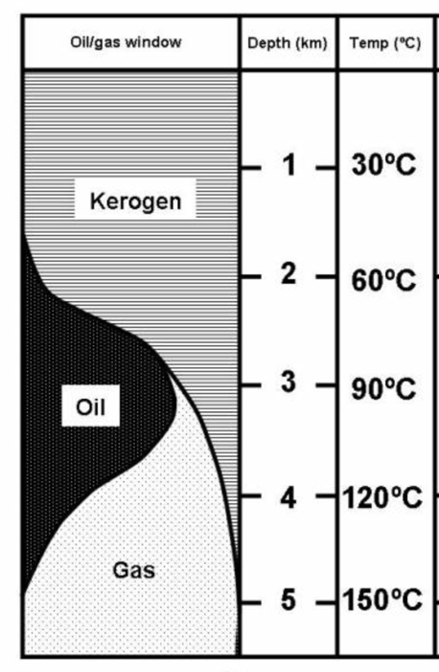As temperatures increase to roughly 30 degrees Celsius and 1km below the surface, *kerogen* - a solid version of hydrocarbon - is formed.

As burial is increased to 3km below the surface and temperatures rise to roughly 90 degrees Celsius, the solid kerogen turns to liquid oil.

Once burial increases to 4-5km and temperatures rise to 150 degrees Celsius, the liquid oil turns to gas.

­

The rock that has produced the oil and gas is known as the *source rock*. If you think about it, if everything continues to get buried, eventually everything would turn into gas eventually, but that is not what happens.

The reason is that the hot oil and gas is less dense than the source rock in which it is produced, and therefore migrates upward through fissures in the rock. Eventually, the hot gas and oil is going to be trapped by an impervious layer of the rock (usually a salt dome), thus forming a pocket of oil and gas which we call *reservoirs*.

*What things do we worry about when we’re trying to get petroleum out of the ground?*

There are a few characteristics of the petroleum that we need to consider before pumping it out.

* Viscosity

*Viscosity:* How viscous/thick petroleum is effects how much energy is needed to obtain the oil from the Earth (more viscosity = more energy needed). The viscosity of the petroleum is dependent on the temperature, and commonly measured by the unit *poise* (or 1/100th of a poise, aka centipoise).

* Sulfur content

If the sulfur content is <0.5%, it is known as *sweet*. At >0.5% sulfur content, it is known as *sour*. The greater amount of sulfur, the greater amount of refining we’re going to need to undergo to make the petroleum into a usable form, so petroleum with lower sulfur content is better

*How do we classify different types of petroleum?*

One way is the API (American Petrochemical Institute) Gravity classification, which measures the density of petroleum in a particular reservoir.

|  |  |  |
| --- | --- | --- |
| **API Gravity** | **Liquid** | **Relative Density** |
| >55 | Condensates | Lightest |
| 38-55 | Light Crude oil |  |
| 22-38 | Medium Crude oil |  |
| 10-22 | Heavy Crude oil |  |
| 10 | Water |  |
| 0-10 | Extra Heavy Crude (Tar Sands / Bitumen) | Heaviest |

What we’re looking for is reservoirs with high APIs because they have the most *paraffins*, or the highest amount of hydrocarbons which provide what we need for gasoline.

As the API decreases, the less percentage of gasoline is available in the petroleum, and the more amount of refining that needs to be done. Most common crude oils have an API gravity between 20 and 45.

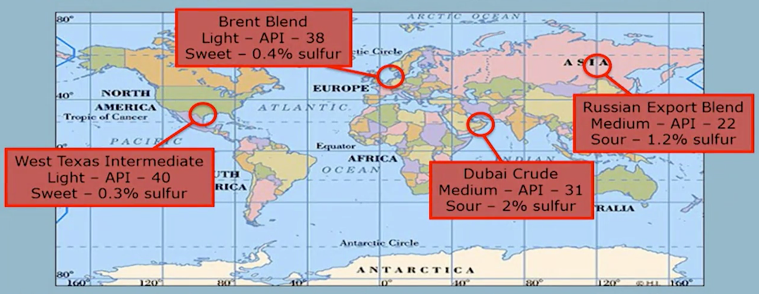The map show of different locations of petroleum reservoirs and the associated API and quality measures at each. The most expensive crude would be the Brent Blend in Europe and the West Texas Intermediate, with a high API gravity value and lower sulfur content. It would also be the most expensive crude at market because less money would be spent on refining.

One of the main reasons why the petroleum found in Russia or Dubai is sour and heavier is because it has been in the ground longer than the sweeter, lighter petroleum located in Europe and West Texas.

*What is petroleum on a molecular level?*

All petroleum are hydrocarbons, and they differ (from a molecular perspective) only in the number of carbon atoms in each molecule, whether the structure is liquid or gas, and whether hydrocarbons are straight or branched. The common characteristic is that all carbon atoms are held together by carbon-carbon single bonds.

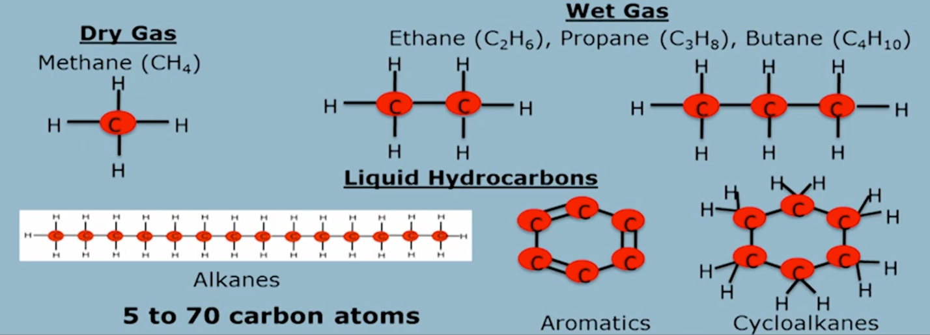

Hydrocarbons with 1-4 carbon atoms are gas (with a further classification of *wet* or *dry* gas, depending on the number of carbon atoms), and any hydrocarbons with 5 tp 70 carbon atoms are liquid at room temperature. Different types of petroleum are classified by the different number of carbon atoms present in its molecules (methane, ethane, propane, butane, gasoline, kerosene, diesel, heavy oil, residue) and the structure of the molecules themselves (aromatics or cycloaromatics, as an example). Aromatics, while useful in other industrial processes, are not useful for the production of gasoline.

The breakdown of different types of molecules typically found in petroleum is found in the pie chart.

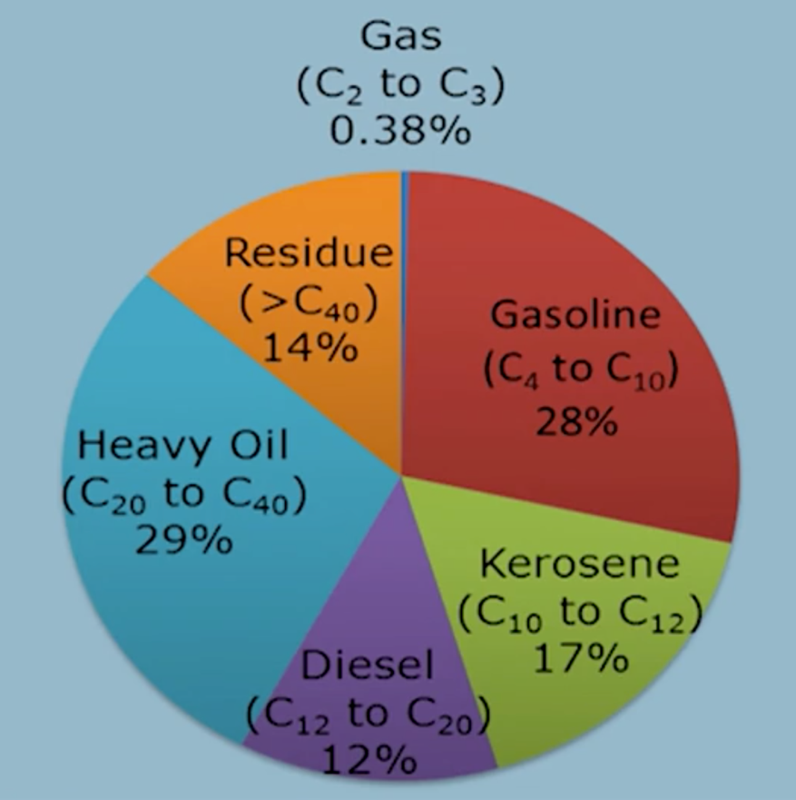Heavy oil and residues are useful in things like greases and asphalt, but the goal of petroleum discovery and refining is to maximize the yield to include the largest amount of gasoline as possible, since that’s what we’re using as a liquid transportation fuel and can command the highest price in the market.

All of these products are derived from petroleum, with the goal – as previously mentioned – to get the most amount of liquid fuel as possible.

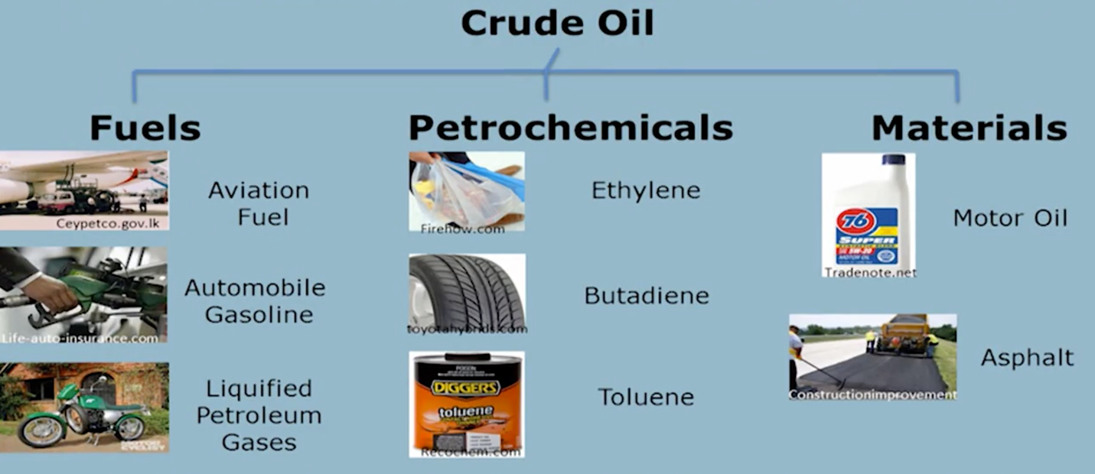

*What are some of the environmental considerations of different components of petroleum?*

Before looking at the actual process of refining, we should take a look at some of the environmental characteristic of the different types of petroleum. Whenever any type of petroleum is burned/used by humans, CO2 (along with water) will be released into the atmosphere.

|  |  |
| --- | --- |
| **Type of molecule** | **Heat / Energy output** |
| Carbon | $$∆H= -393\frac{kJ}{mol {CO}_{2}}$$ |
| Liquid (octane) | $$∆H= -679\frac{kJ}{mol {CO}_{2}}$$ |
| Natural gas (methane) | $$∆H= -890\frac{kJ}{mol {CO}_{2}}$$ |

From an environmental standpoint, natural gas is the best out of the three options in the table because you get the most amount of energy per mol of CO2. In other words, when you combust a methane bond by exposing it to oxygen (and using the power generated by that process), you break the molecular bonds of methane and create CO2 and H2O. You get the most amount of energy by combusting methane when comparing it against carbon or liquid.

You also need to look at the density of each type of molecule. A positive of a solid like coal is that it contains the most amount of energy per unit volume, while a positive of gas is that its speed of combustion is very quick relative to liquid or solids (this speed of combustion can be a disadvantage because of safety concerns however). Additionally, solids are easiest to store while gases are the most difficult. The combination found in liquid fuels – density close to that of coal, with a reactivity closer to gas – make it the most attractive type of fuel.

*How do we create fuels from crude oil?*

There are three stages of oil refining: Distillation/Separation, Conversion/Cracking, and finally Treatment/Enhancement

1. Distillation

At a high level, we separate the compounds based on differences in their boiling points. We take the crude oil, heat it up to an extremely high temperature (>1000 degrees Fahrenheit), and pass it into a *distillation column*. At the bottom of the column we have the highest temperatures (600 degrees Celsius) while at the top the temperature decreases (20 Celsius). Different compounds move up the column if they are less dense or gaseous and their boiling points are relatively low, while compounds with high boiling points stay at the bottom.

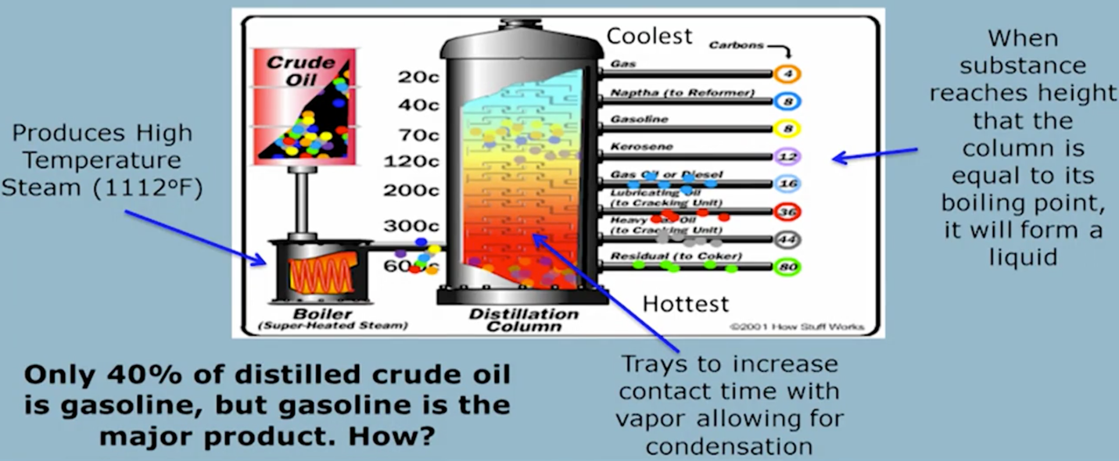

Once the compounds have reached the appropriate location in the distillation column depending on their boiling point, we then *fractionate* the same kinds of compounds at different points in the distillation column (called *fractions*) – gas at the top, kerosene and diesel toward the middle, and heavy crude at the bottom.

Doing this would produce ~40% gasoline, but since the point of refining is to get the highest percentage of gasoline possible, we want to convert the less useful compounds to gasoline, which is what the next step does

1. Conversion/Cracking

The heavier fractions have more carbon atoms within their molecules than gasoline, so this step is all about breaking these hydrocarbons located toward the bottom of the distillation column into smaller pieces to increase the value of the final product.

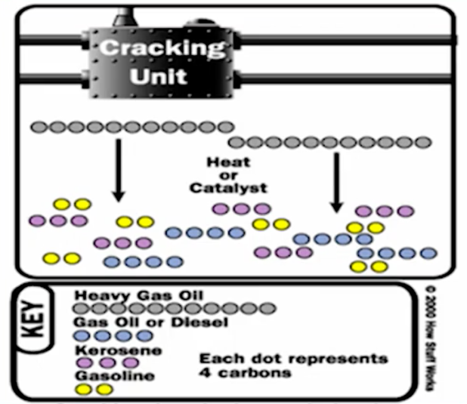We *crack* these hydrocarbons one of two ways: *thermal cracking* or *catalytic cracking*

*Thermal cracking:* The heat from the steam or residue breaks apart the carbon-carbon bonds of heavier compounds

*Catalytic cracking:* A catalyst speeds up the process of breaking the carbon-carbon bonds into molecules with fewer carbon elements.

Once the hydrocarbons are cracked, they go into another fractional distillation process to yield more gasoline

1. Treatment/Enhancement

Finally, we get rid of the contaminants included in each type of compound. Removal of sulfur is especially prevalent in this part of the process (and why reservoirs with lower sulfur content are more valuable). Nitrogen, oxygen, dissolved metals and inorganic salts are also removed from the hydrocarbons.

The *Claus process* separates sulfur from the useable hydrocarbons, specifically by heating the hydrocarbons in a furnace, and then combining sulfur dioxide to distill the sulfur out of the hydrocarbons and into H2O and liquid sulfur waste from the process. 99.8% of sulfur is distilled out of the useable hydrocarbons.

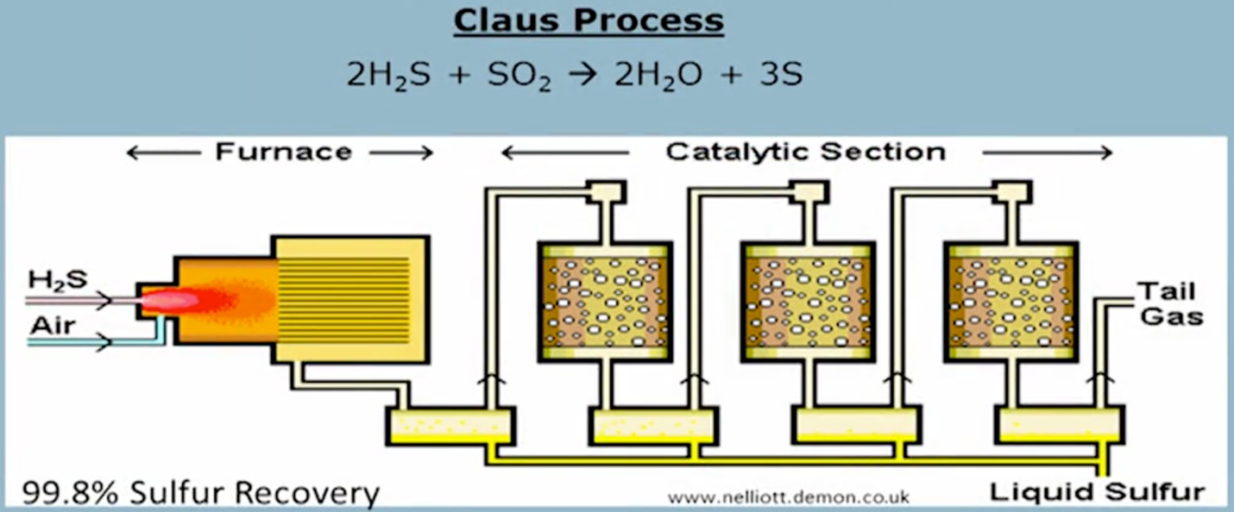

The entire refining process results in 50% gasoline, 30% fuel oil, and 7.5% jet fuel.

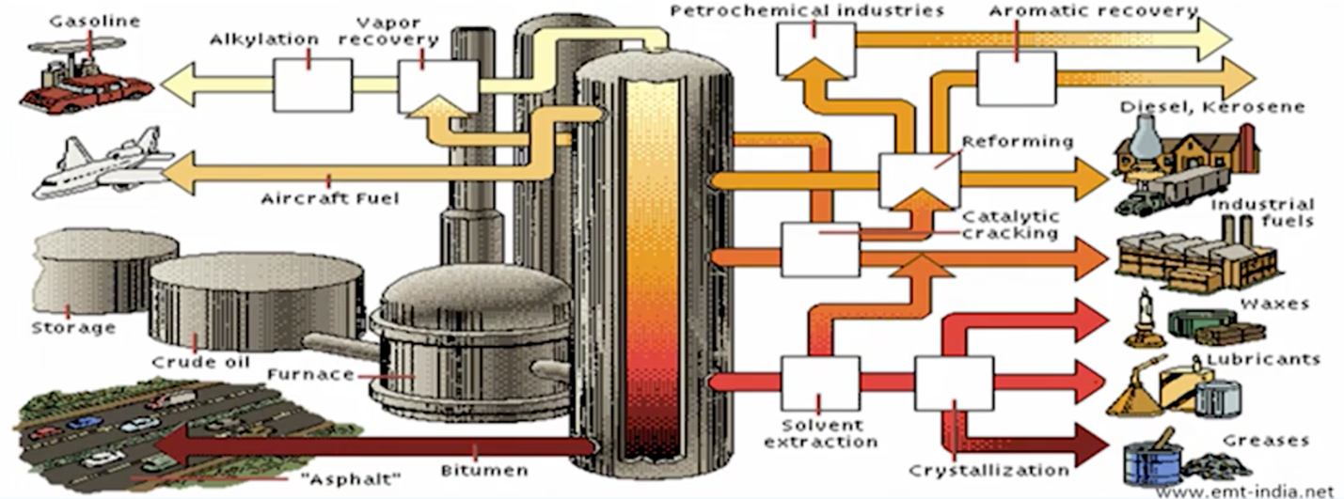

*Why do we use gasoline in our engines?*

When cars were first invented, we used ethanol and some peanut oil to power the engines, but moved to gasoline in the early 1900s. There were a couple reasons for this:

* Gasoline is cheaper than ethanol to produce
* Chemically speaking, there are a couple important properties – water doesn’t mix with it so there isn’t an issue of water in the gas tank, and gasoline can be still for a long period of time without microbes (harmful to the engine) forming
* Rockefeller, who produced kerosene for lamps from petroleum, actually threw away gasoline at the time because it wasn’t used in anything profitable. He convinced Henry Ford to use gasoline to power cars’ engines

*What are some issues with replacing petroleum with renewable, biofuels?*

Although biofuels are renewable, it is still resource-intensive in different ways. First is that producing biofuels requires land, and clearing that land with results in a loss of carbon. Secondly, in the course of refining biofuels, massive amounts of water are being used or the raw materials being turned into fuel are food commodities which could drive up the price of food and make water even more scarce than it is now.

Another consideration is that we need to figure out a way to recycle/recover key nutrients for producing biomass, namely phosphorous and nitrogen; currently there does not exist a way to recycle and reuse those nutrients. If we don’t find a way, we’d essentially be replacing one finite resource (petroleum) with another (phosphorous)